Theme Development

04 Theme dev

Place holder Screenshot

Tony Evans

See next page for screenshots of what your page should look like

In this folder you can see the following:

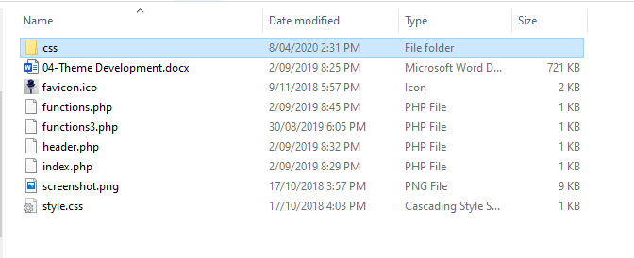

The files in this folder should be the same as 03 Theme Development. The root folder style.css file is still the same but just updated for the theme name.

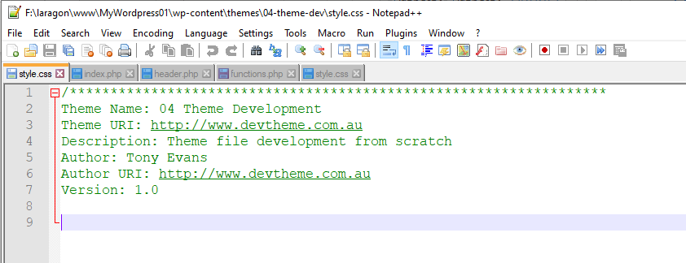

Open the “index.php” to see what has been included. It should look like the screen shot below.

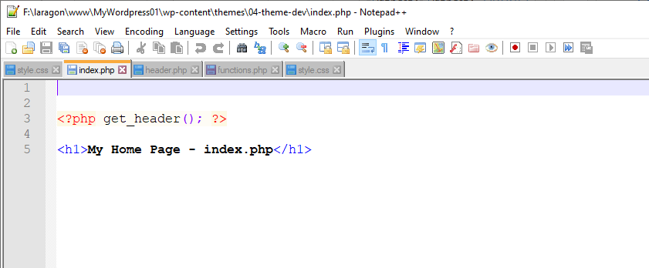

The header.php file should look like the one below. The title has bee changed to more appropriate site title. In this case MyStyle. This would be your client page title.

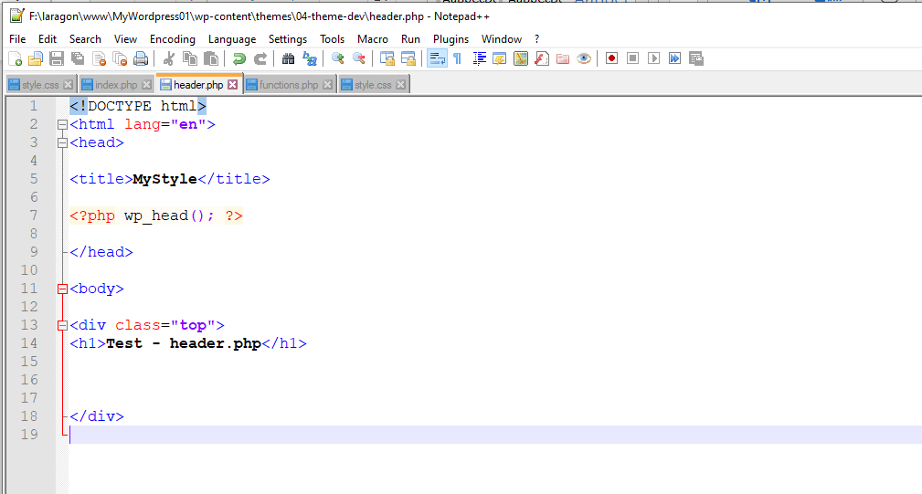

The functions.php file should look like the one below. Containing the enqueue code for the location of your css style sheet. As you may have noticed that the style.css has changed to mystyle.css. This is to help with any confusion between the main root css style sheet having the same name:

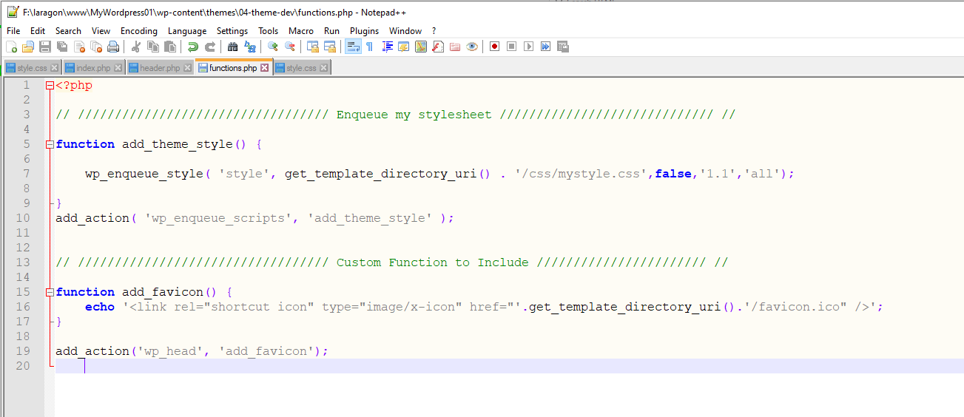

When this theme has been activated you should be seeing “04-Theme Development”, a screen with the index page and the header page.

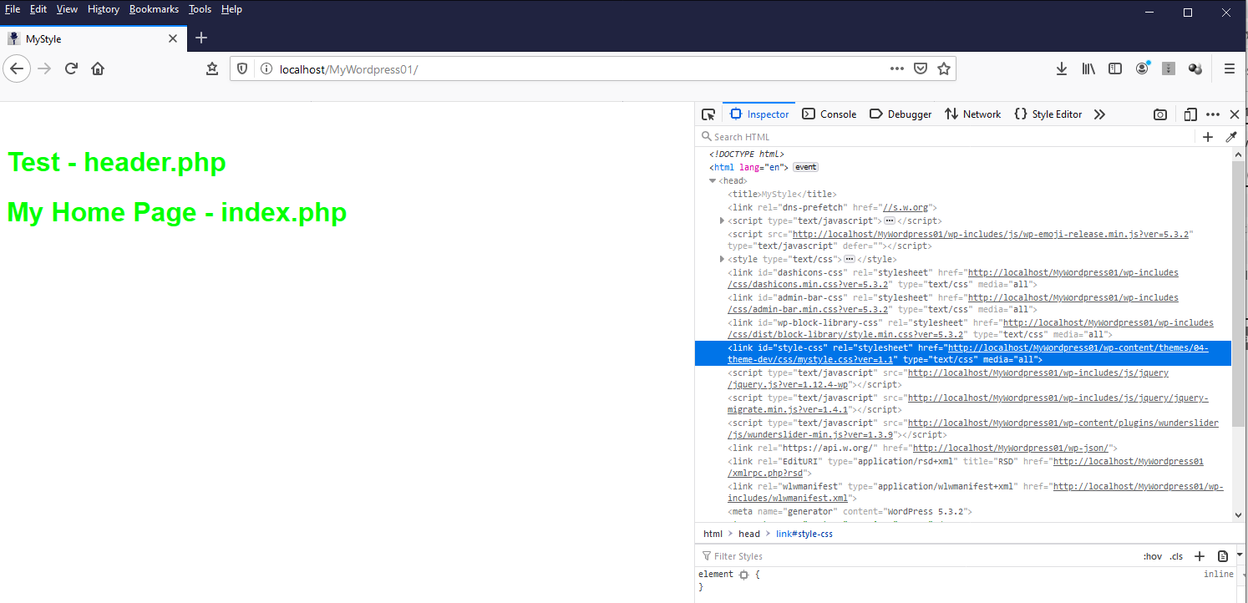

You can also see in the above screen the Web Developer tools showing the mystyle.css file attached.

# Menus

To start adding a menu to your site you will need to edit the “functions.php”. You need to register your menu or menus if you want more than one. This sets the name that will appear **Customise -> Menus**.

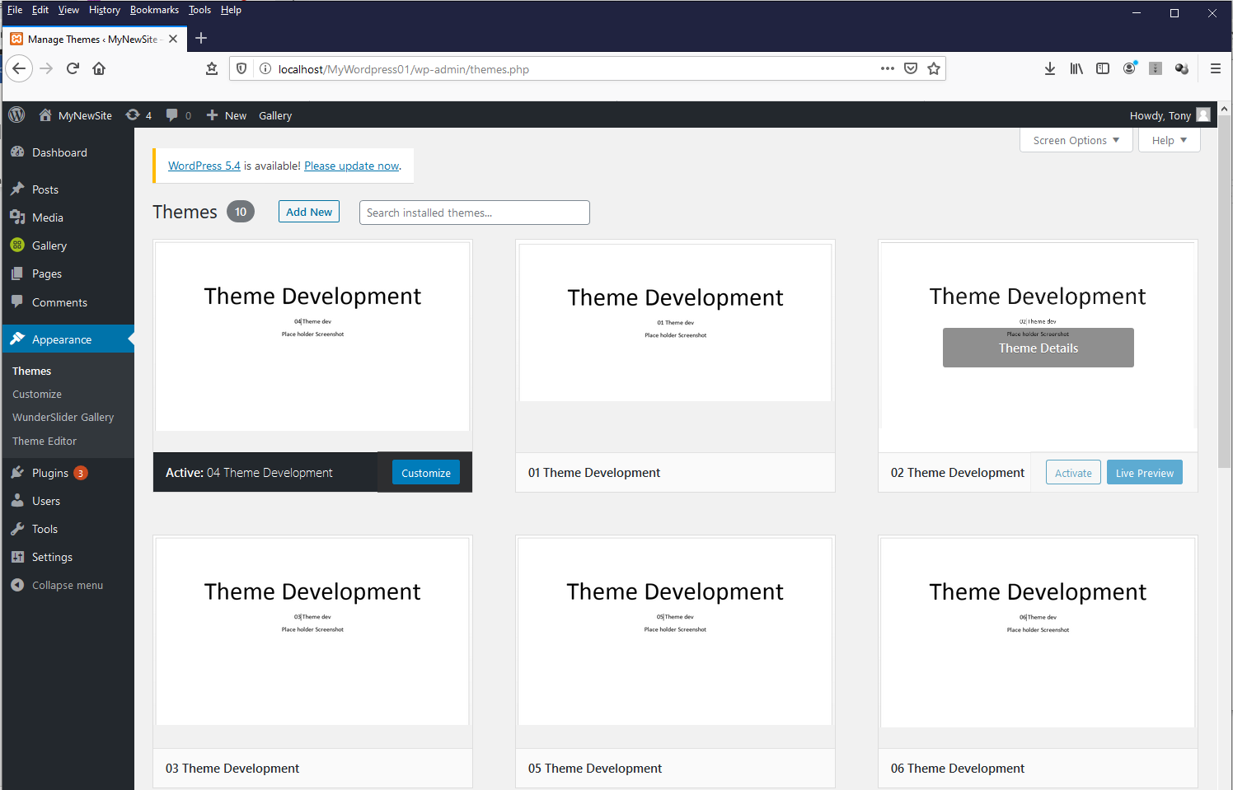

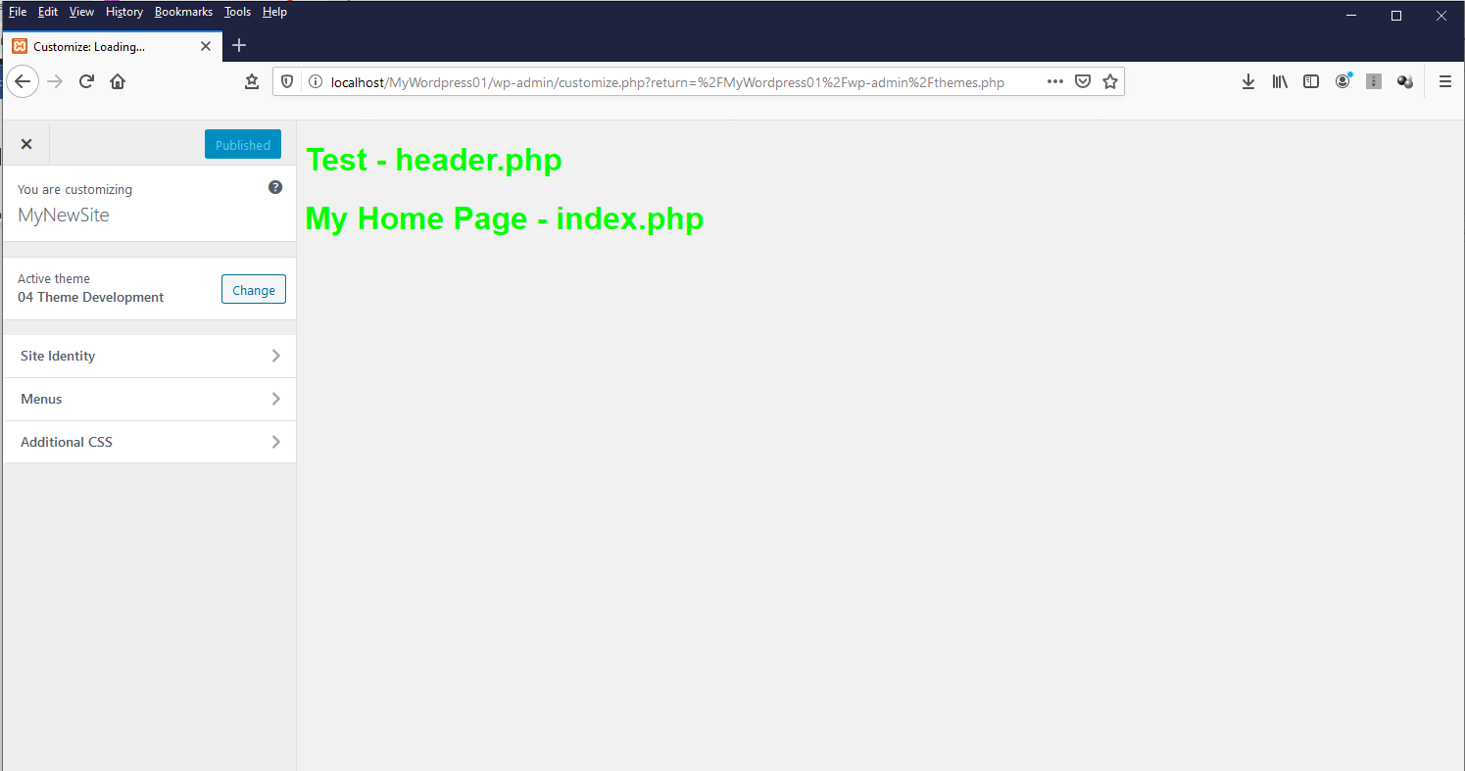

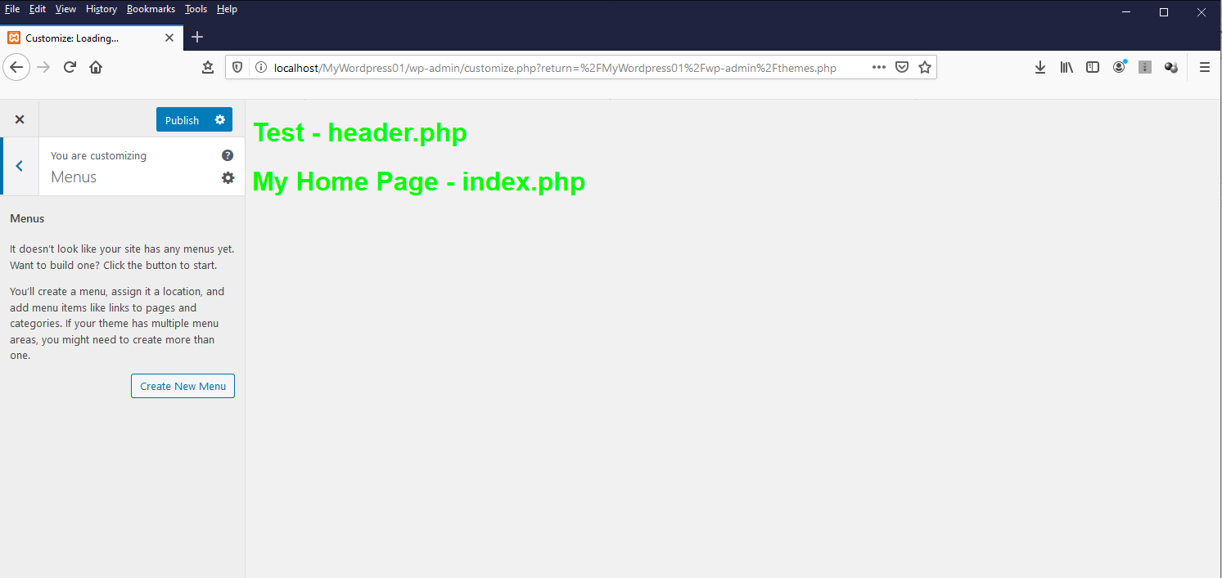

The above shots show that there are no menus in this site. If you have created any menus before they will show up here, so it may not look like the screens above.

Now open the “functions.php” file and look at the code. You may need to un- comment the menu function.

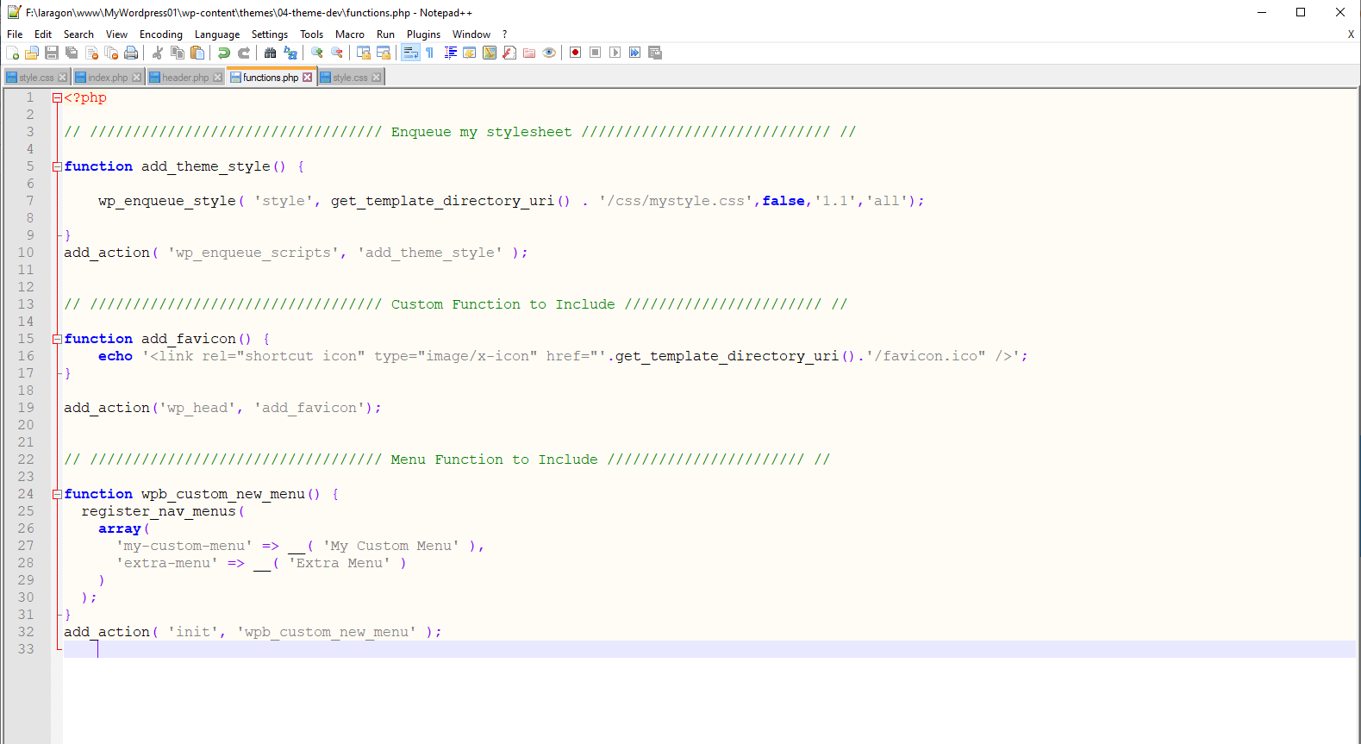

Now go back to the main admin panel in WordPress and you should see a menu item appear in the list under Appearance.

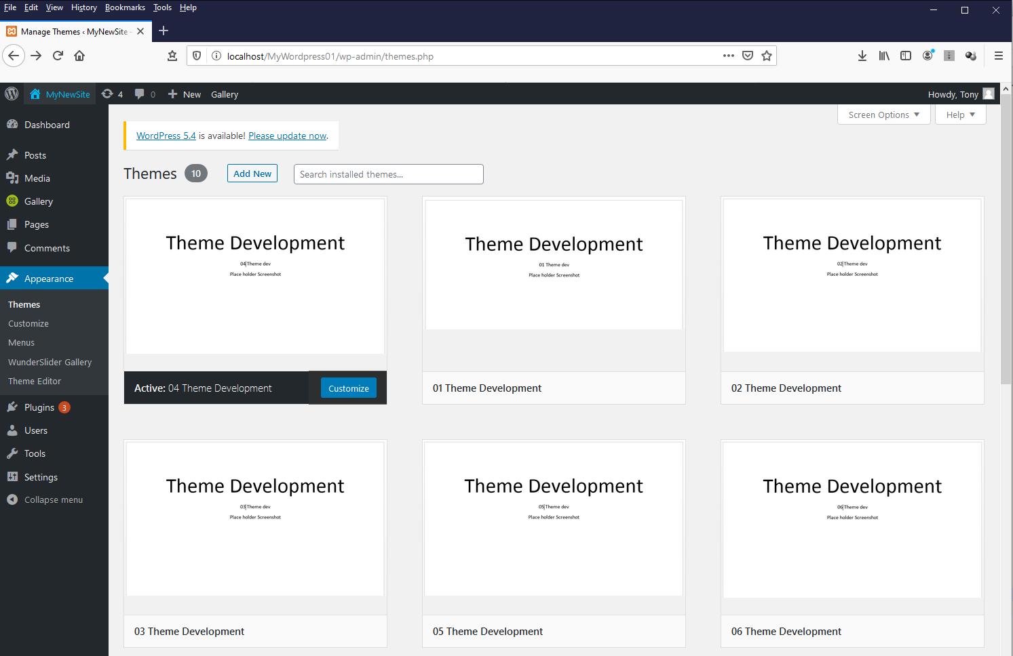

Click on the new item Menus and look at the next screen.

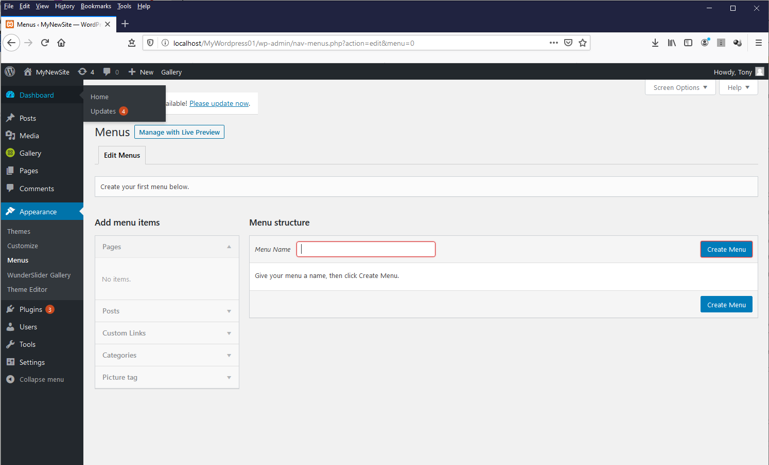

Enter a name for your new menu and click Create Menu.

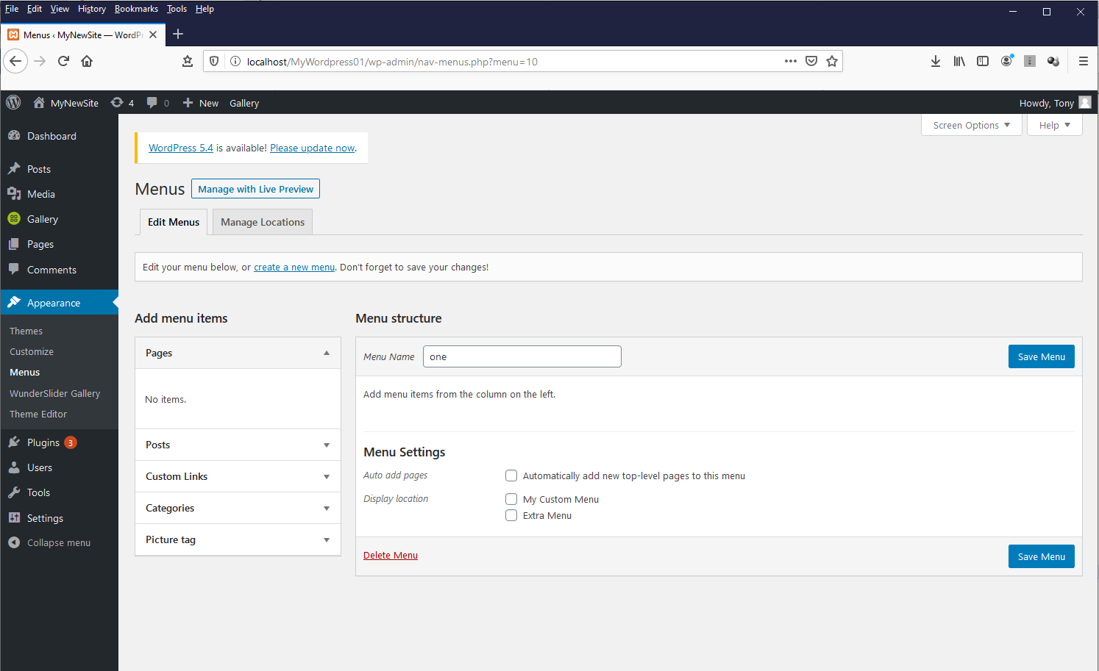

Once created there should now be appearing the “My Custom Menu” and “Extra Menu” menu items that are specified in the “functions.php” file.

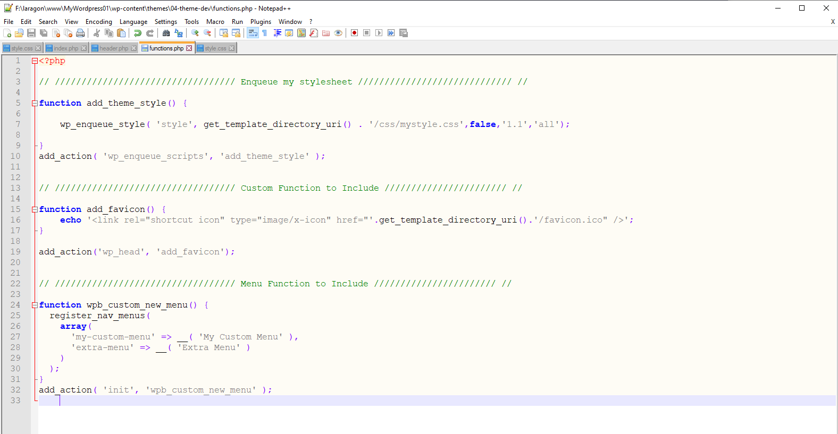

Select the “My Custom Menu” and then save.

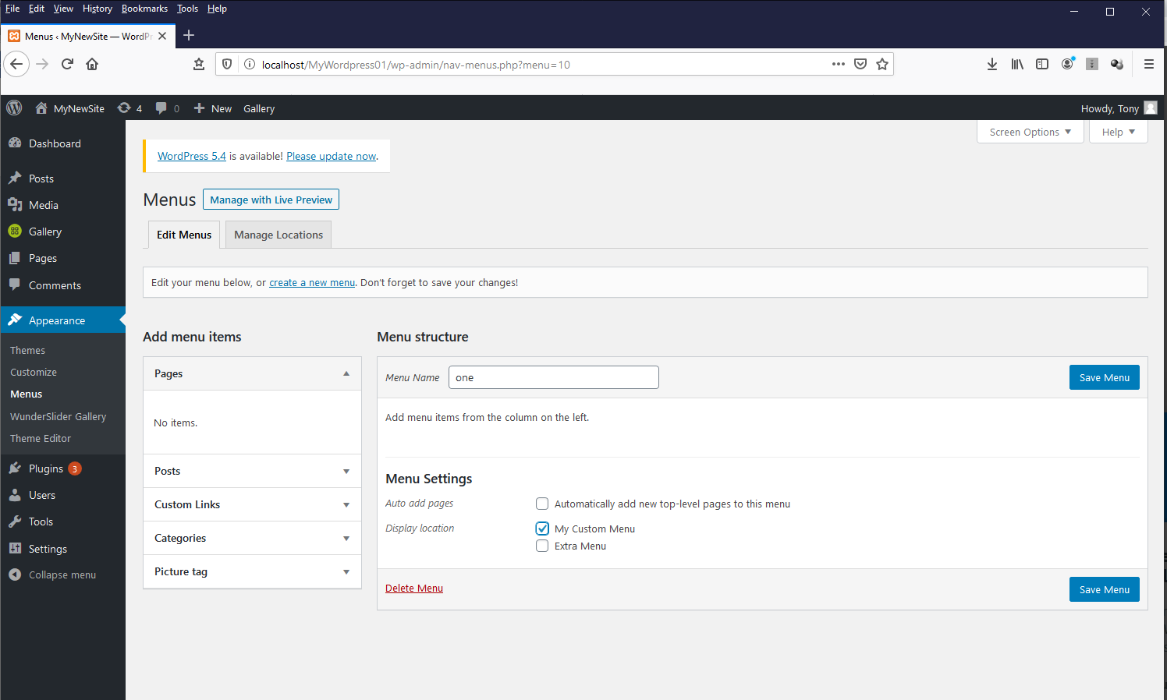

Click on manage locations and you should see the new menu name.

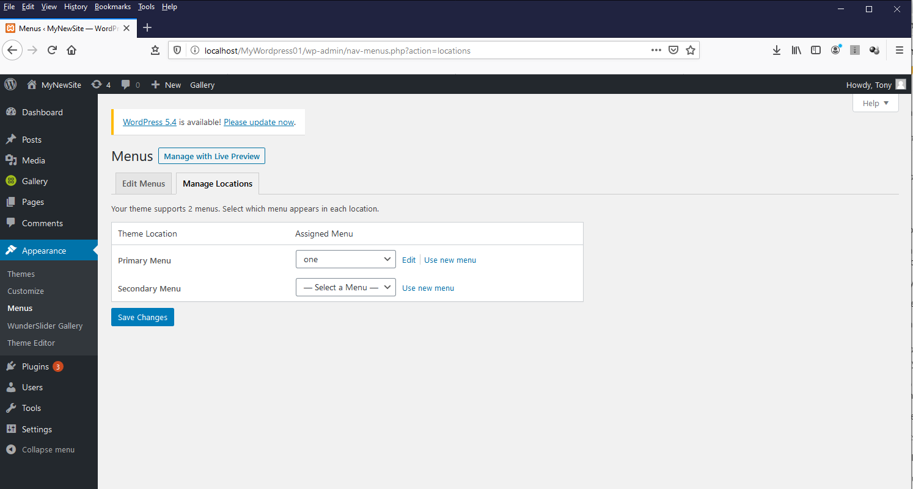

If you wanted to create a second menu then this can be done by adding another name.

After saving your menu have a look at the site.

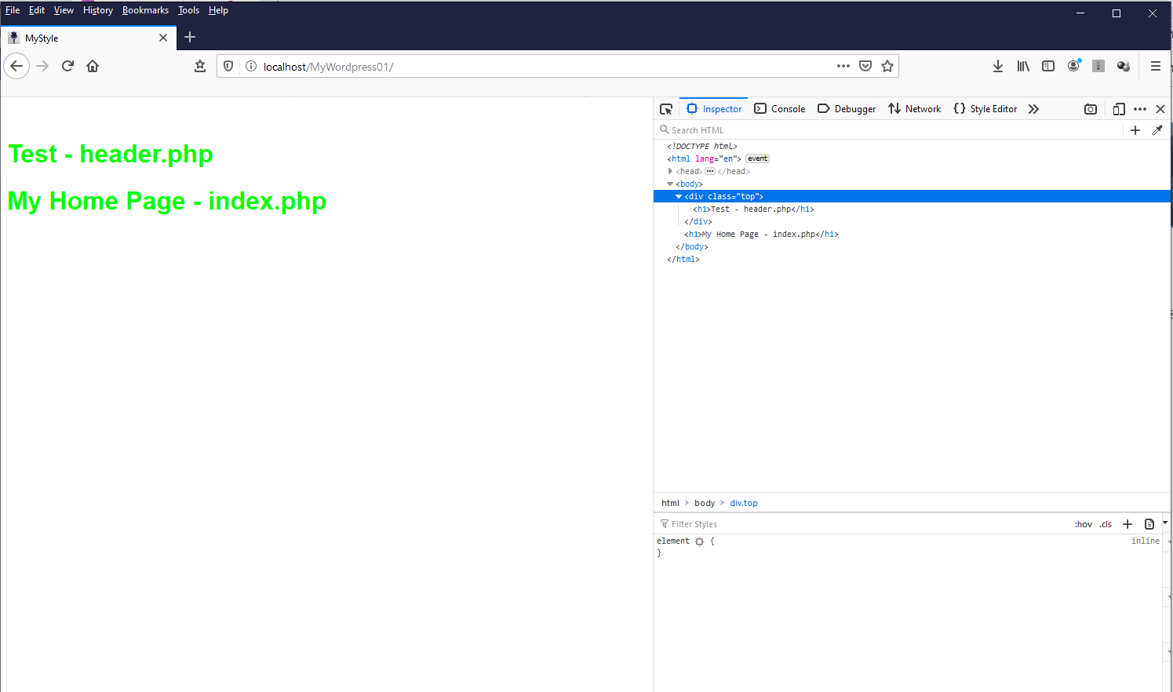

Still no menu available even if you look at the Developer tools window.

So, what does this mean? The menu has been created but has not been place anywhere.

Are there any Pages??

This is also the reason why nothing is appearing. So, let’s create a page to put in our menu. Return to the admin panel and click on pages.

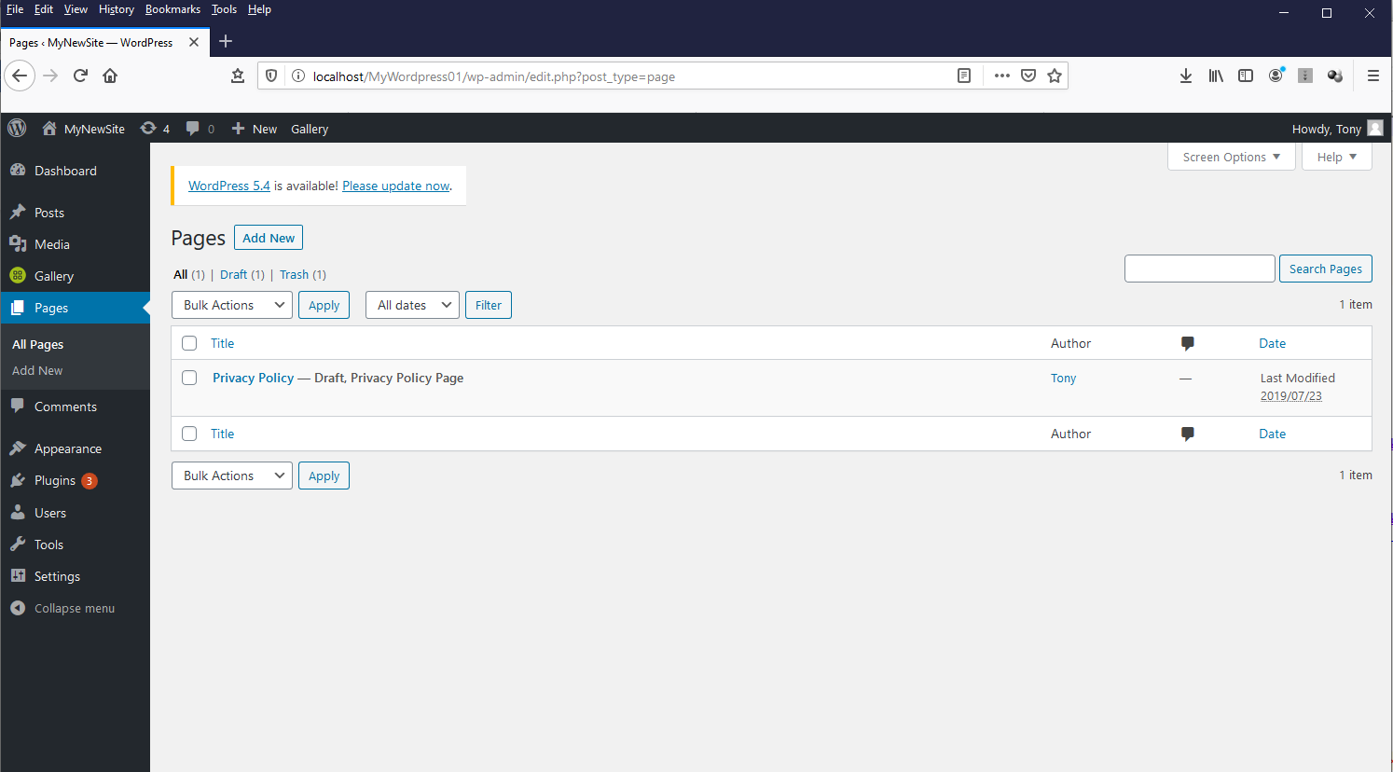

Click “Add New” to create a new page. In the updated version of WordPress there is a new way of editing pages called blocks. These make it very easy to add content.

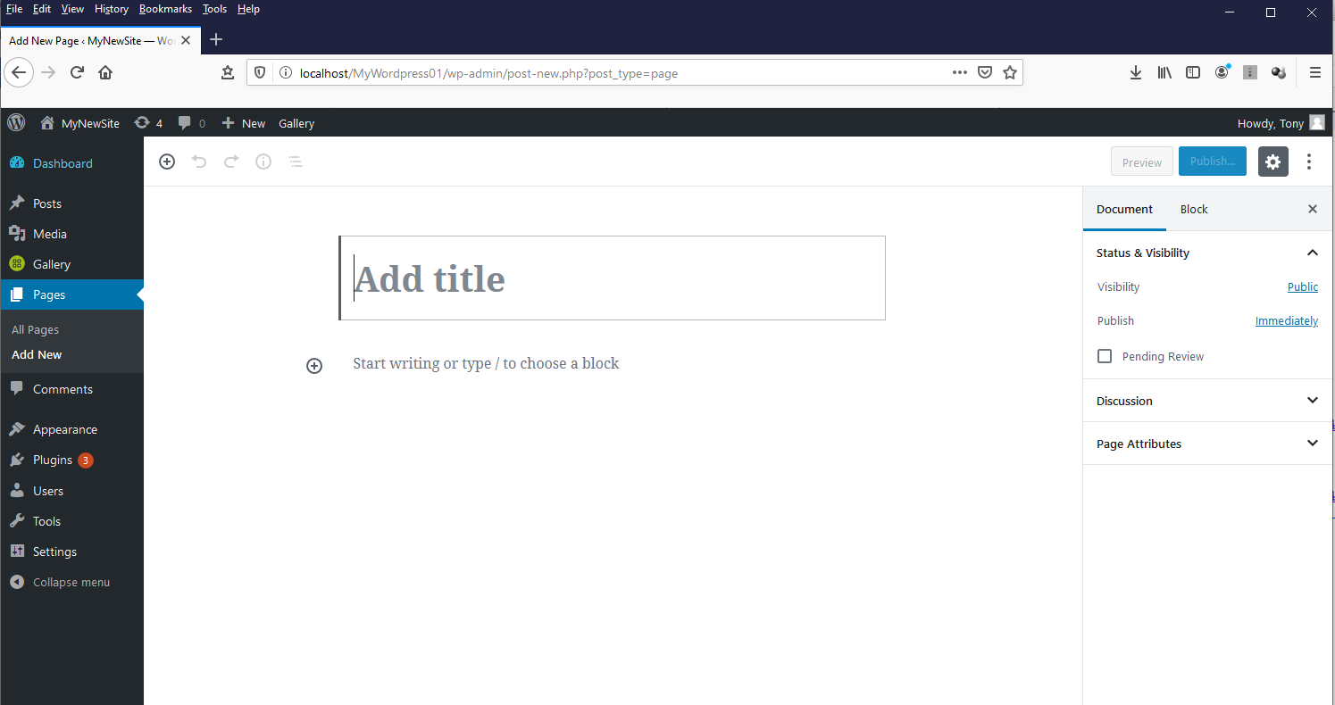

Call this one “About” and add a title and some content. Then create another page called “Contact” with some content. These are typical pages that would exist in a website.

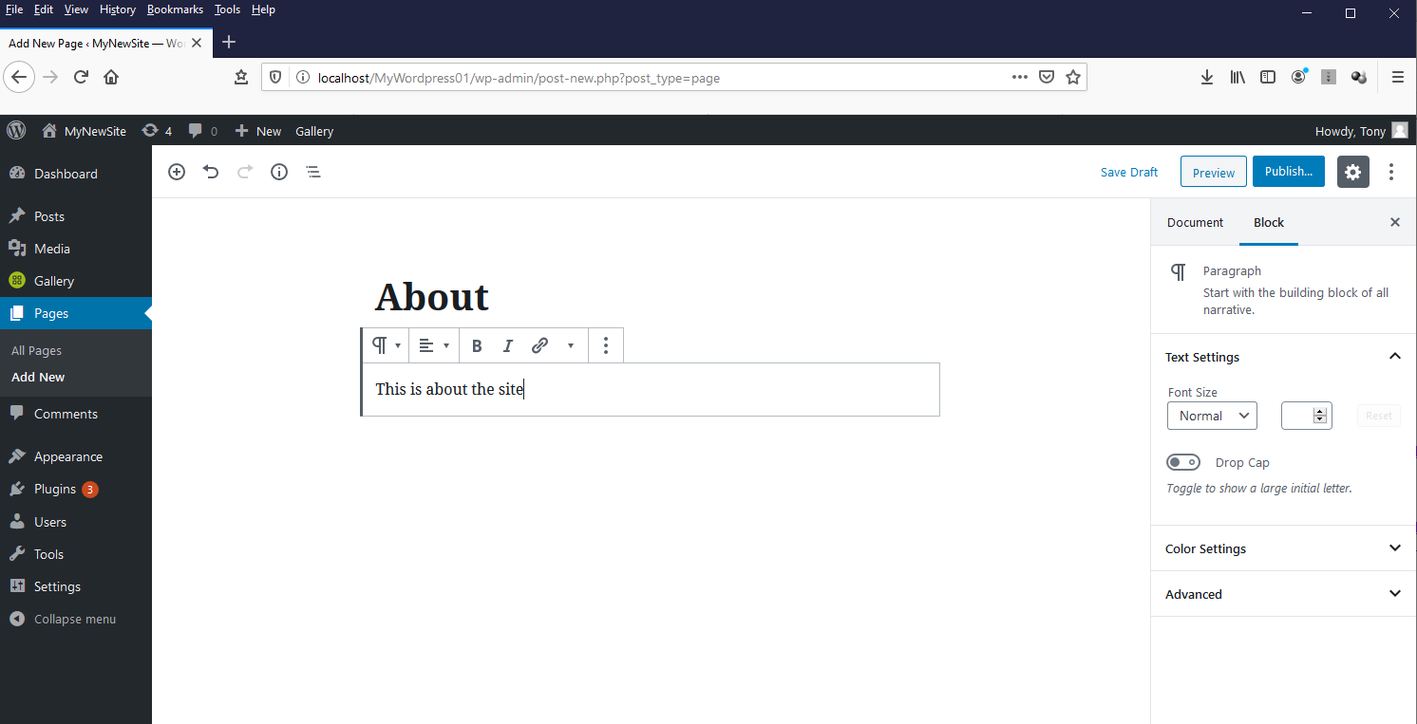

Publish the page to save it.

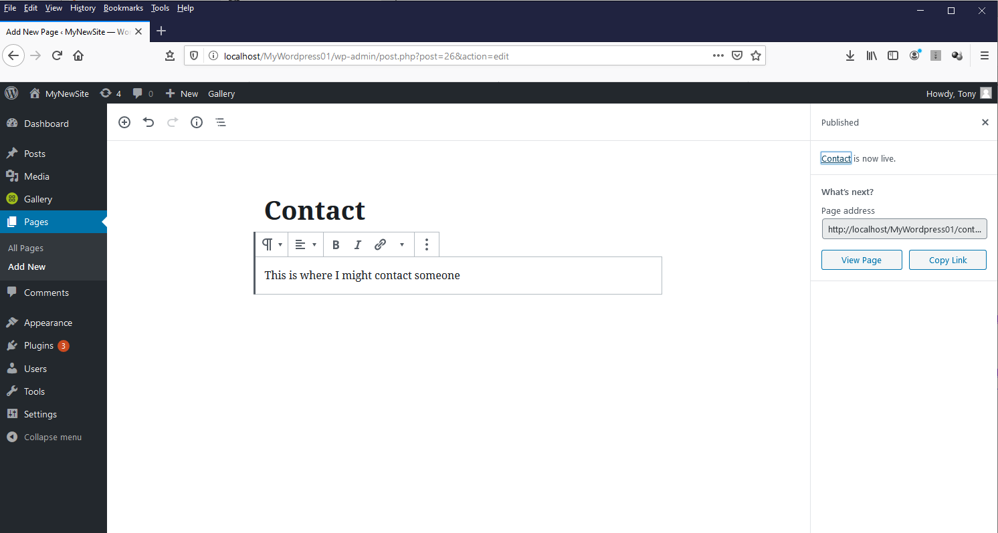

Now go back to the admin panel and click the menus item.

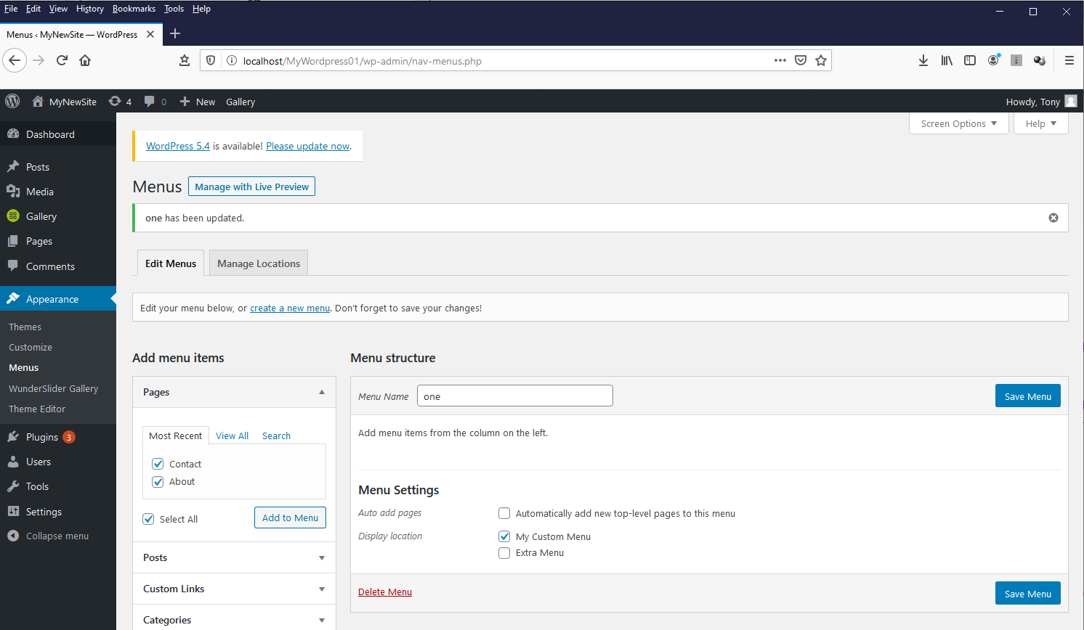

You will now see the new pages that you have created. The next step is to add them to the menu bar that you created.

Click the “Add to Menu” button to add to the menu.

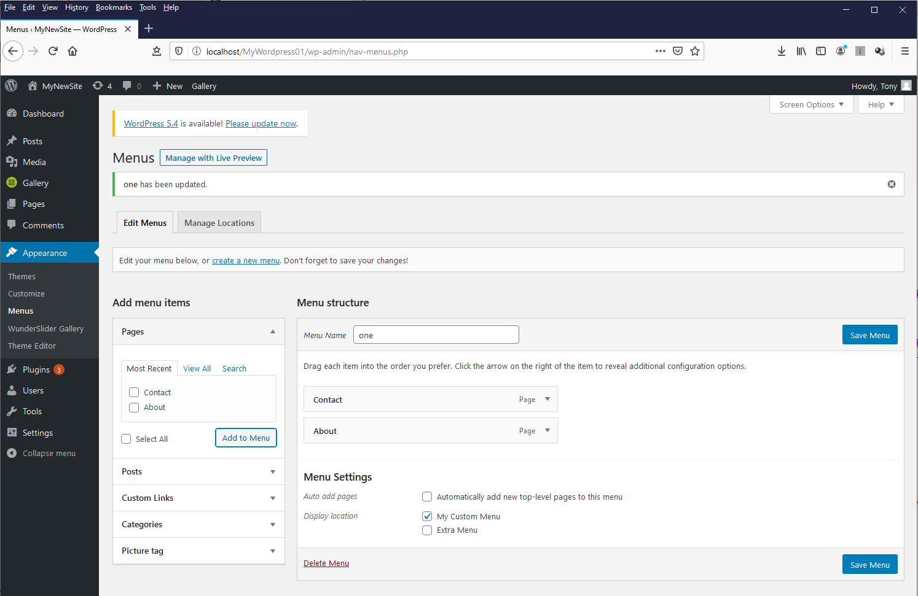

Don’t forget to save the menu!!!

Now view the site to see the menu items.

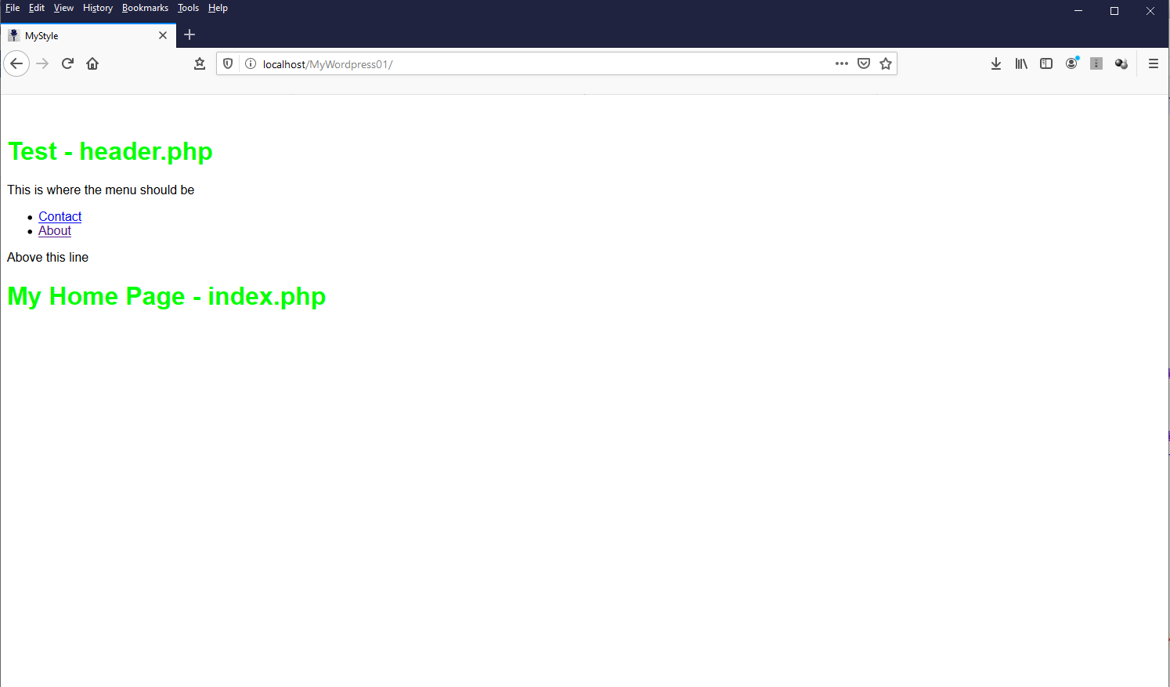

Let’s style this up.

Open mystyle.css and add the following code (or un-comment if you have the code files).

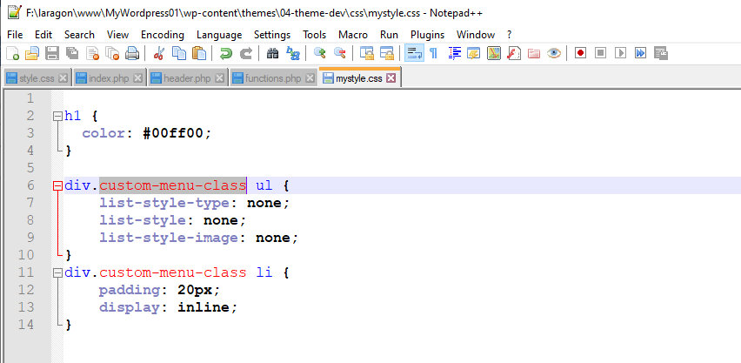

Next create a “div” and a “class” for your menu in the “header.php” file.

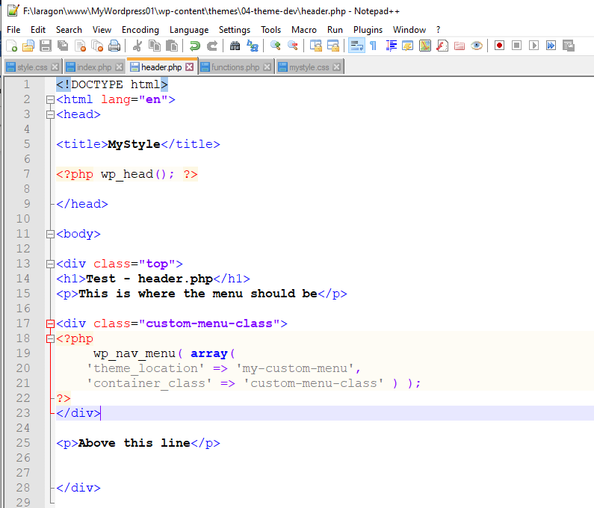

Then see if it worked in the browser.

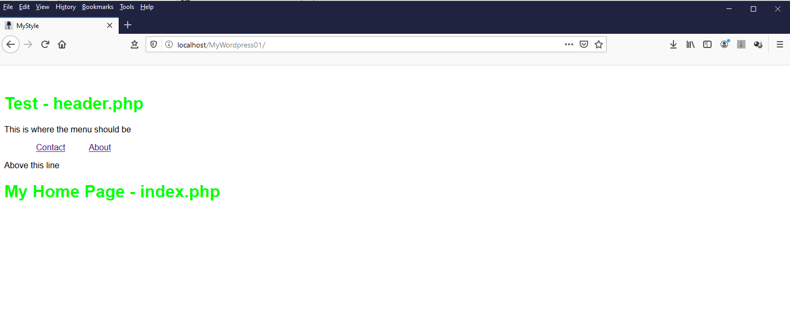

We can start to work on the next steps. See 05-Theme Development